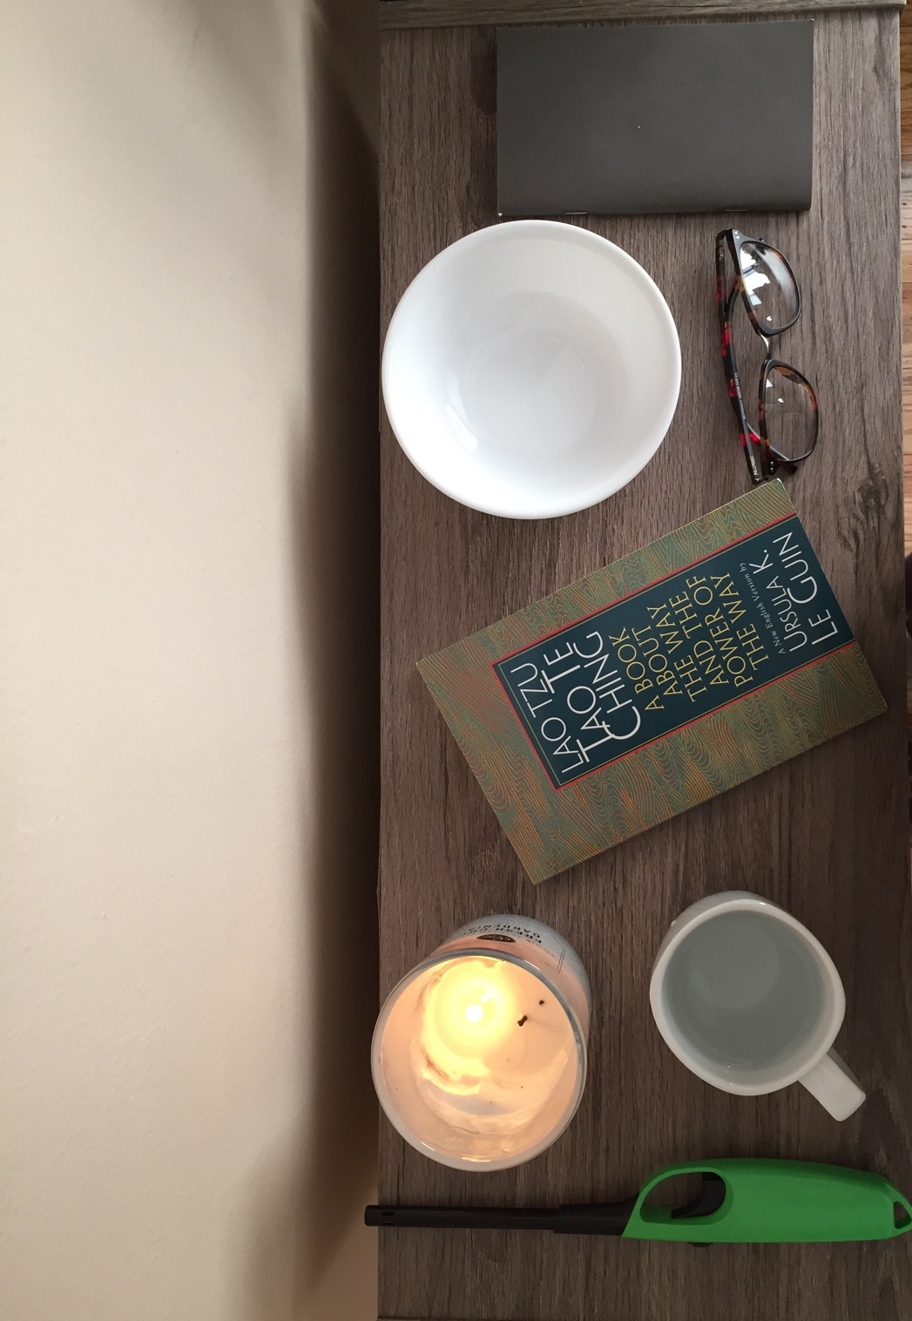

Tuan Nguyen

Book Bento for Lao Tzu: Tao Te Ching A Book about the Way and the Power of the Way by Ursula K. Le Guin

Candle and lighter

The candle can’t be light without a lighter. Like food and water come in handy together. For example, in chapter 2 “Soul food” Le Guin says, “For being and nonbeing arise together; hard and easy complete each other; long and short shape each other.” One thing is depended on another thing to complete. Can't-miss one or another. Like the candle needed a lighter to make it bright and shine. Moreover, Le Guin emphasizes the comparison between value and belief are an interplay of yin and yang. Yin and yang are demonstrated the balance of life, such as the candle and lighter depend on each other.

Glass of water

Water is pure, colorless, and fresh. Water brings the life to the animal and plants. Plants need water to grow and transform. Animals need water to survive under any conditions. Water is medicine to heal the earth. For instance, in chapter 8 “Easy by nature” Le Guin addresses the true goodness is like water. Water is good for everything. Water flows from one place to another place. It strengths never weaken or stop. The concept of water is unconditional endless. Similarly, the glass of water is continuous hold water. Water is a main theme throughout Lao Tzu short poem. Lao Tzu constantly mentions water in different ways from one poem to another, such as water is the central of life and humanity.

Empty bowl

The missing component in the bowl is food or vegetable. The peace and happiness are intervolved within another. Life without happiness would be tasteless and bland. Peace makes people feel secure and grateful. For example, in chapter 30 “Not making war” Le Guin describes war is violence and tactic. To win the war, the loss of happiness must exchange for the victory. Every battle comes a sacrifice of love one. Another example, in chapter 31 “Against war” Le Guin mentions “Weapon are unhappy tools. It’s only be used when there is no choice. To enjoy using weapons is to enjoy killing people.” A beginning of a war is the loss of peace and happiness. Soldiers are laid down to protect their nations. Like the empty bowl shows the missing of food and peace.

Glasses

Glasses are used to improve the vision of eyes. Seeing things clearer is to examine its truth and virtual. For example, in chapter 17 “Acting simply” Le Guin examines the true leader is hardly known to their followers. A true leader is who people know and admire. To trust without worry. To live without fear. A true leader makes people feel trustful and protectives. Like, an example of the glasses is used to view the detail and different aspect of the leader. Similarly, in chapter 20 “Being different” Le Guin mentions the difference between yes and no is the matter of right or wrong. The answer can be either right or wrong depending on who answers it. For instance, a smart leader will lead the battle to victory while a poor leader will be defeat. The glasses can be used to see the capability and aspect of the leader.

A Journal

A Journal or diary records a time, places, and events that happen in the past and present. The mysterious and private makes a journal invulnerable. To read a journal is like finding treasures. It contains unreadable information about the writer. However, the one who gets to read it might not admire the ideas of the writer. For instance, in chapter 70 “Being obscure” Le Guin says, “My words are so easy to understand, so easy to follow and yet nobody in the world understand or follow them.” Lao Tzu teaching about humanity and morality can be easy to read but hard to understand. Like, a journal can be readable but difficult to understand because of it remains mysterious.